**Home**

**Pictures, videos etc…**

Serving the Pakistani market since 1945, PPM Chemicals is an established name when it comes to specialty chemicals, photochemistry, and related products. PPM has grown into the largest photochemistry wholesale and distributor in Pakistan and has diversified into various other specialty chemicals.Our headquarters are in Lahore with regional offices in Karachi, Rawalpindi, and Sargodha.

**ABOUT US**

The group started its business in 1945 dealing in the wholesale & imports of photographic material later on started with the darkroom equipment like enlargers, timers, photographic chemistries, color, and black & white paper & other consumables items associated with this industry and achieved the highest level of confidence throughout the country of our valuable customers after many years of hard-working and good services. This resulted in us starting trading in 1983 by importing color chemistry mini lab labs and photographic color paper in 1993 as we became the sole distributor of l.b Russell Photographics Chemistry New Jersey U.S.A later known as Champion Photochemistry, Rochester USA. We were appointed the sole distributor for Pakistan in 1999 and later on, we set up a network of our sub-distributor throughout the country from Karachi, Lahore & Rawalpindi to handle and control our photochemistry business. We have been rated as the highest taxpayer in the National Photo Finishing Market. And we also have a strong and influential penal in our local Chamber Of Commerce and Industry and associated business clubs.

We have been winning awards continuously from 2003 to 2010 for our sales performances including the “best marketing excellence award” and “chemical specialist award 2004, 2006, 2009”. The second phase of our achievements had given us the confidence to come into the field of refurbished photofinishing analog and digital machines firstly we started the import of photofinishing machines from Japan in 2000 and successfully installed more than 800 analog machines. We, later on, led the market move to digital printing selling refurbished digital machines - we have installed twenty machines of 12” and five machines of 24” throughout the country and they are running successfully with the full assistance and support of our skilled engineers and skilled staff under the supervision of our efficient admin team.

With over 400 dealers across the country we have a strong presence in Pakistan and in the global photochemistry market along with a rising presence in other chemical and additive products:

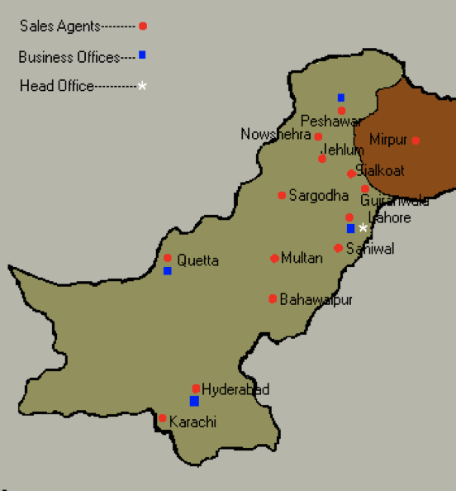

Our success has been spearheaded by our strong team of engineers, sales, and admin staff and is a result of our commitment towards our customers and maintaining high ethical and professional standards. PPM Chemicals is known in Pakistan today for its honesty and commitment.

We are the authorized distributors and dealers in Pakistan for many world-leading companies including the following:

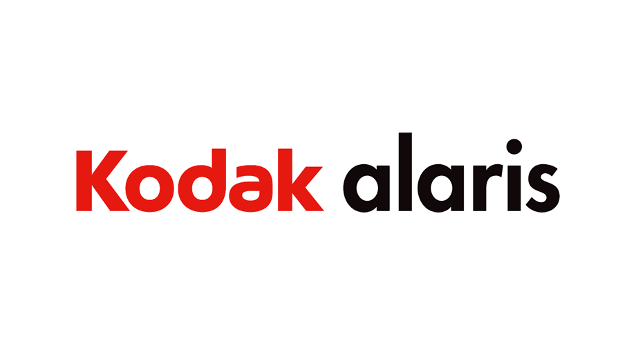

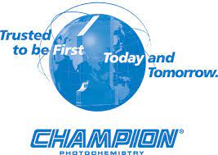





**OUR NETWORK**

We are situated in the main and largest Photographic Market in Lahore the second largest city of Pakistan, running with three sister concerns on the same platform, these are PPM Trading House, PPM Digital Color Labs & PPM Professional & Technical Services.

**PPM TRADING DIVISION**

This unit deals in trading of all sorts of stocks regarding the regular consumption items of the Photo Products i.e Noritsu Digital Brand New Machines - JAPAN, REFURBISHED DIGITAL MACHINES LIKE KONICA SUPER R1 & R2, FUJI FRONTIER 340, 350, 355, 370, 375 from USA & Japan, TURA PLATINUM/ADVANCE Digital Color Paper - GERMANY, KODAK EDGE COLOUR PAPER -the USA, SUPRA DIGITAL PHOTO PAPER-CHINA, MI COLOR PAPER –CHINA, KUDOS INKJET PAPER, JIANGSU NAISI DIGITAL TECHNOLOGY – CHINA, Album Making, creasing & sealing Machines from Double 100 – China, minilab consumables & spare parts from TECHNOTAPE - HOLLAND. It fulfills the requirements of small business unitholders, as well as the bulk parties.

**PPM DIGITAL COLOR LABS DIVISION**

This unit is the eldest among the house and deals, directly with Customer Services i.e. color laboratory requirements, photo finishing, etc. It occupies four labs in the local market and nine labs at different outstations. We are the one and only among the local labs, who are providing lab services, Twenty-four hours a day, seven days a week. Digital Labs are equipped with the latest Digital Equipment. To date, we are the only one in Punjab province who have installed the “NORITSU 3701HD, THE LATEST DIGITAL FULLY EQUIPPED MINILAB SYSTEM”. We have the leading role in introducing the latest technology to our market

**PPM PROFESSIONAL & TECHNICAL DIVISION**

This is the unit that maintains coordination among other concerns engaged in Imports, Distribution, and Brand/Product Promotional activities, also acting as representatives. This not just deals in the imports of the demanded products but also supervises, instructs, and monitors its own distribution network, spread all over the country. Currently, we are dealing in NORITSU BRAND NEW MINILABS SYSTEM, Photographic Chemicals from Champion photochemistry _ Malaysia, Album making, creasing and sealing Machines, TURA PLATINUM / ADVANCE Photographic Digital Color Paper from Germany, Kodak Edge color paper, Mi color paper, Supra digital photo paper from AL BARSHAA UAE. Photographic material like lamination material and Color Labs & Accessories, etc. as our technical staff is highly professional including 6 Engineers and 12 Skilled technical workers, and 8 helpers.

We are the pioneers of digital album making in Pakistan and work closely with leading photographers and various brands. Our sister concerns M.M Digital Color Lab, MAX II Digital Color Lab & MAX Digital Color Lab are located on self-owned properties working with cutting-edge equipment.

As we look towards expanding into different industries and markets, we continuously develop our existing marketing network.

**CONTACT US**

| Head Office | Foto Imaging Arcade, 1 - Mission Road near Masjid Mai Lado. Lahore, Pakistan  TEL: +92-423-7223693, 37211574 & 75. E-MAIL: ppmchemicals1@hotmail.com |
| --- | --- |
| Karachi Office | Champion Traders. 14 - FB Area, Munawar Center |
| Sargodha Office | Sky Color Lab, Khyam Chowk Sargodha |
| Rawalpindi Office | Rawal Digital Lab, Aziz Bhatti Road Lal Kurti |

**FOOTER**

**FOTO IMAGING ARCADE, 1 - MISSION ROAD NEAR MASJID MAI LADO, LAHORE – PAKISTAN**

**TEL: +92-423-7223693, 37211574 & 75. FAX: +92-423-7241573.**

**E-MAIL:** ppmchemicals1@hotmail.com